To: Dr. Trevas

From: Alec Boyce, Ryan Fortier, Davis Geniza, Oscar Nunez, Zhiyu Wang

Date: October 16, 2020

Subject: Implementation Memo 2

# Implementation – Weeks 7-11(Davis)

Implementation of our design and changes to the design from week 7 to week 11 of the semester are displayed and commented on in this section. Specifically, manufacturing processes of the dipper and its specifications are detailed in section 1.1. Design changes in section 1.2 explore the addition of the newly designed rotating arm. This design was adapted from the original concept of rotating the arm of the excavator using the wheels. This design change required redesigning most of the arm, and instead of fixing the arm to the base of the excavator it is attached to a tower enabling it to rotate when digging. Lastly, a more complete CAD assembly is discussed, which includes components that were missing in earlier CAD renditions, such as the inverter, batteries, and hydraulic pump.

## Manufacturing (Alec)

The manufacturing process of the new arm design will include welding, cutting, and drilling. Figure 1 shows the dipper to further specify manufacturing techniques.

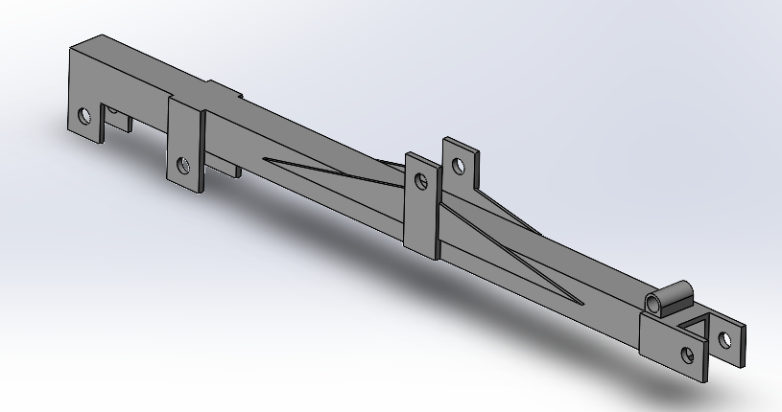

**Figure 1:** Dipper

The main component of the dipper is 2” x 2” steel square tubing that is .25” thick. The team will need to cut the tube to the proper length of 36 inches prior to any other manufacturing. The next step will be to cut the rectangular and triangular pieces of steel from a .3 inch thick piece of steel plating. One the steel plates are cut, the team will need to use a drill or some variant of cutting tool to cut the .75 inch diameter holes seen in Figure 1. Lastly, the team will need to weld the steel plates onto the steel tubing in the specified locations. These same steps will be repeated for the manufacturing of the tower, boom, battery box and base.

## Design Changes -Weeks 7-11(Ryan)

The design changes made in weeks 7 through 11 include an arm redesign, mounting of the hydraulic pump, and mounting of the power inverter. Figure 2 shows the redesigned arm in a fully retracted position.

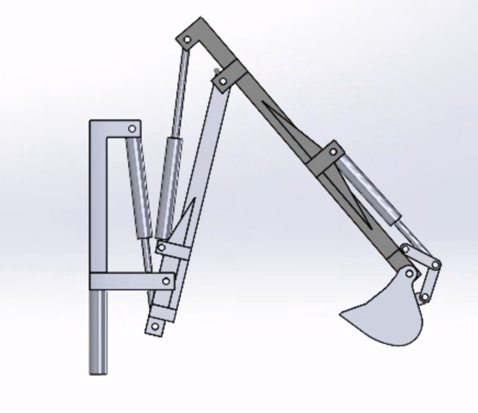

**Figure 2:** Arm in Retracted Position

The new arm design features a tower, which will mount to the base of the design. The tower allows for a 3 ram design instead of the traditional 4 ram design. The reduced number of necessary rams lowers cost and weight and allows the team to use the hydraulic manifold provided. The tower also allows for the tower to rotate in the future, due to the centralized cylindrical mounting. The new style of arm attachment allows the hydraulic pump provided to the team to be mounted to the body in between the arm and the battery box, as shown in Figure 3.

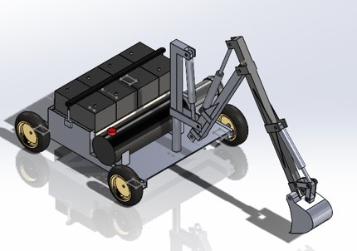

**Figure 3:** Visual of Fully Assembled Design

This mounting position is ideal for the pump because it is close to the arm which results in a shorter total length of hose from the pump to the rams. Additionally, the pump is close to the power source which will eliminate long wires that may interfere with moving parts. Although the batteries are very close to the pump, the pump will need to be plugged into the power inverter that is mounted on the opposite side of the battery box as shown in Figure 4.

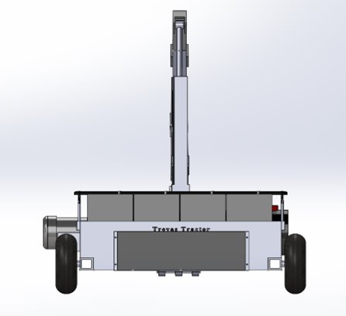

**Figure 4:** Rear View of Fully Assembled Design

The dark rectangular figure is the power inverter and will transform the power proved from the batteries in series, into consumable power for the pump, motors and Arduino equipment.

# Standards, Codes, and Regulations (Oscar)

The importance of Standards, Codes, and Regulations in engineering is not something that is generally regarded with much importance. However, in the field of engineering it is these sets of standards that set apart the amateur work form the professional work. Without these standards it would almost be impossible to keep up with new innovations. As part of the responsibility of these standards is to keep track and document any technical criteria, methods employed, processes used and practices that may have been followed. Without any of these standards in place none of this would be feasible as it is the documentation of these standards that allow us as engineers to comfortably upgrade systems, interchange movable parts and most importantly ensure us that proper safety, quality and reliability are being employed. In the following table we illustrate the standards that we have employed thus far however as our excavator has not been fully manufactured we still do not have a full list of all the standards that our team employed in the completion of this project.

## Standards applied to project

|  |  |  |
| --- | --- | --- |
| **Standard Number or Code** | **Title of Standard** | **How it applied to Project** |
| SAE J296 | Mini excavator and backhoe bucket volumetric rating | Used to determine the heaped bucket capacity |
| SAE J1179 | Surface Vehicle Standards - Hydraulic Excavator and Backhoe Digging Forces | Used to determine the digging forces according to the standards |

# Risk Analysis and Mitigation (Zhiyu)

This part will introduce the defects and risk assessment of the products designed by the existing team. This will include the design of the existing team and the introduction of potential failures in the system. Finally, this part will provide solutions to this risk.

## Potential Failures Identified Fall Semester

The team divided the excavator design into dase design, arm design, electrical system design, battery design and hydraulic system design. Remote control excavators need to be able to dig a trench that is a foot in depth and six inches in width and batteries should be able to operate for a full workday . In order to fulfill this requirement, the team designed a different arm and base design for other excavators.

The new arm design reduces the number of necessary plungers (Figure 2), but it also makes the arm connected to the base bear excessive pressure, which may cause structural fracture during the operation of the excavator. This may lead to potential failure.

## Risk Mitigation

In order to prevent potential failures, the team needs to conduct force analysis on the excavator work and conduct fracture analysis on the arm structure. This can help the team understand the working limits of the excavator. At the same time, the team also needs to modify the arm structure to reduce potential failures caused by structural fracture.